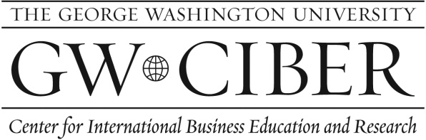IVEY
CASE WRITING WORKSHOP

Preliminary Teaching Note: COPTIC ORPHANS

OPENING PARAGRAPH

In late 2006, Nermien Riad, CEO of US-based Coptic Orphans (CO) learned that their Cairo partner for the girls mentoring program would no longer provide logistical support to this, their second pilot site. Ms. Riad wondered whether or not to continue this program for scaling up CO’s impact on children’s injustices in Egypt.

TEACHING OBJECTIVES:

- To assess scaling up opportunities in terms of organization identity and comparative advantages.

- To learn about matching growth opportunities to organization capacity (including staff growth and partnerships).

IMMEDIATE ISSUES

- Is the Valuable Girl Project consistent with CO’s organization identity and comparative advantages?

- Is the growth so far and continuing growth a good fit with CO’s organization capacity?

BASIC ISSUES

- Scaling up while maintaining organization identity.

- Scaling up while effectively managing growth and capacity, including staff socialization, and partner management.

Suggested Student Assignment

Question 1: Assess the Valuable Girl Project in terms of CO’s organization identity and comparative advantages.

Question 2: Assess the Valuable Girl Project in terms of CO’s organization capacity (including staff growth and partnerships).

Question 3: Given these assessments and the Cairo Father’s withdrawal from the Project, which of the following options would you recommend and why?

- End the Valuable Girl Project and continue to grow the successful direct assistance program.

- End the Valuable Girl Project in Ezbit el Haganna but explore other site options for expansion.

- Replicate the Valuable Girl Project in multiple sites and find a new partner in Ezbit el Haganna.

The Actual Decision

CO found a new NGO partner, Caritas, near Ezbit el Haganna. It was near enough that they could continue VGP with the same girls without interruption. In 2005, CO decided to expand VGP to 12 sites throughout Egypt. By the end of 2005, more than 500 girls were being served and CO was working with 8 different partners; these partners included NGOs, community development associations, schools, and churches. The growth of both VGP and Not Alone led to CO doubling its staff in both Egypt and Virginia.

In 2006, CO received a $50,000 grant from the US Embassy and was serving more than 530 girls. It had grown from a $1 million nonprofit in 2004 to over $2 million in 2006. CO was now receiving attention from the international development industry, with invitations to participate in panel discussions on girls education. In 2006, a US-based international development NGO asked to visit VGP to learn more about it on the ground. Following that visit, it requested CO to become its partner to further scale up the program. Riad assessed CO’s organization capacity and decided they were not yet ready for this kind of scaling up through partnership. Specifically, her Egypt-based staff were not responding to emails and deadlines as quickly as they used to. She worried that they were either at their capacity or needed additional coaching on US styles of doing business. The NGO continues to ask when she will change her mind….

